4 DAYS 3 NIGHTS KUALA LUMPUR + MALACCA PACKAGE

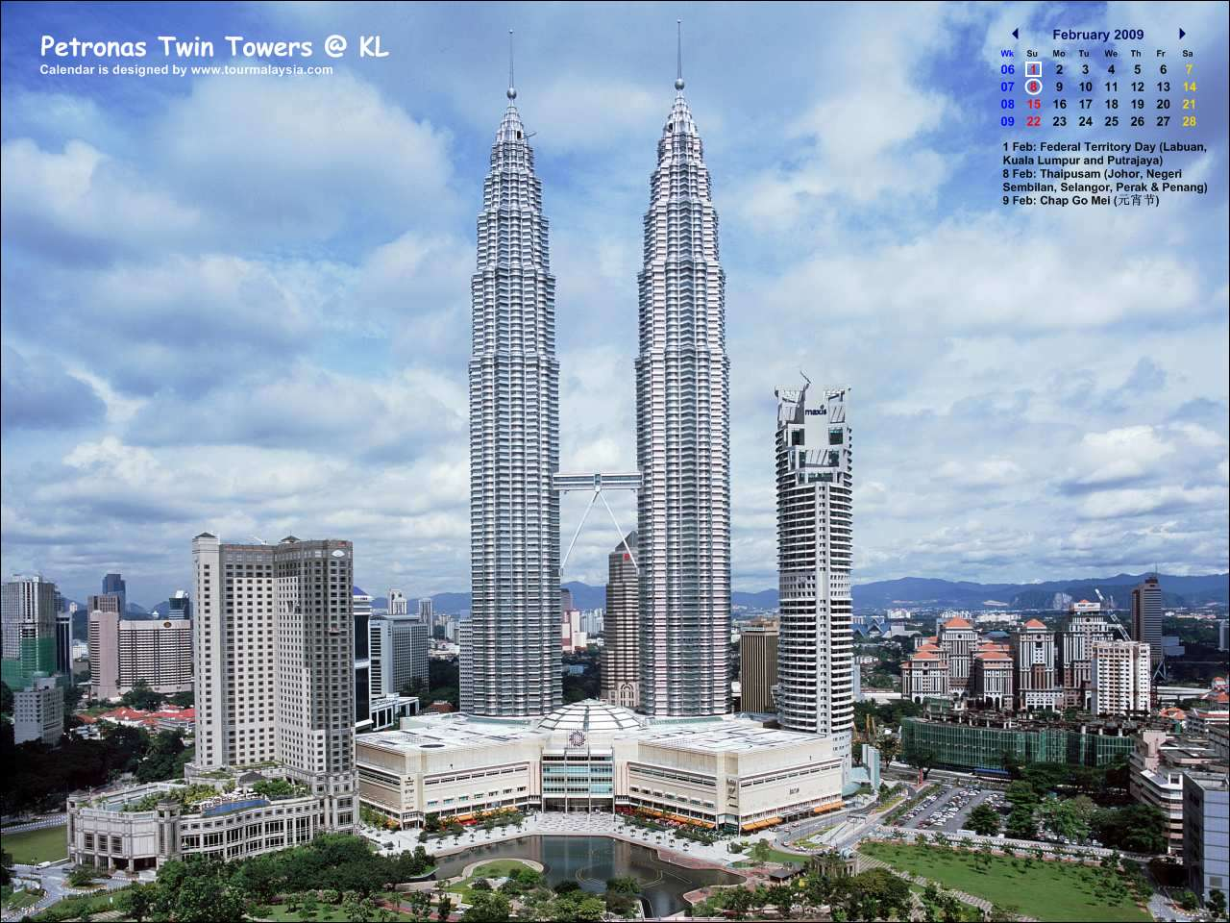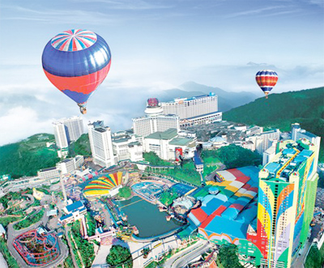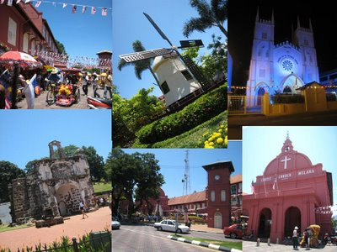

Hotel | Twin / Triple  (per person) | Child with extra bed | Child without bed | Single supplement additional
Sentral Pudu Hotel | RM 7055.00 | RM 560.00 | RM 420.00 | RM 250.00
Coronade Hotel | RM 870.00 | RM 690.00 | RM 520.00 | RM 415.00
Maya Hotel | RM 1070.00 | RM 850.00 | RM 650.00 | RM 615.00

ITINERARY :

Day 1 ARRIVE KUALA LUMPUR
Arrive KUALA LUMPUR airport , check in hotel .

Day 2 KUALA LUMPUR (BREAKFAST)
Breakfast at hotel, proceed to Kuala Lumpur half day City tour – National Monument , Independence Square , National Mosque , King Palace , Petronas Twin Tower ( photo stop) . Afternoon , free at leisure .
Overnite Kuala Lumpur .

Day 3 MALACCA DAY TRIP (BREAKFAST)
Breakfast at hotel, proceed to Malacca Tour – Visit St Paul Church , Jonker Street , A Famosa Fort ,
Baba Byonya , Cheng Hoon Teng Temple . Overnite Kuala Lumpur .
Day 04 KUALA LUMPUR – OUT ( BREAKFAST)
Breakfast at hotel , free at leisure until transfer to airport for your departure .
Package Inclusive :
~ Transfer in/out.
~ 3 Nights accommodation (Twin sharing).
~ 3 Breakfast.
~ Half day Kuala Lumpur tour (seat in coach)
~ full day Malacca / Genting tour

Package EXCLUDED :
~ Personal expenses.
~ Tipping.
~ Travel Insurance.
~ Domestic air ticket
~ Entrance for sightseeing

REMARKS :
~ Rate is based on minimum 02 paxs and above.
~ The Hotel reserve all rights
~ Validity : Until March 2012.
~ All rate quoted is base on RINGGIT MALAYSIA

PEAK SEASON SURCHARGE :-
~ Sentral Pudu hotel additional surcharge @ RM 50.00 per room per night on 24 – 26 Dec &
31 Dec – 01 Jan 2012.
~ Coronade Hotel additional surcharge @ RM 35.00 per room per night on 01 – 31 Dec 2011 .
~ Coronade Hotel compulsory dinner on Christmas Eve & Day @ RM 100.00 per adult
~ Coronade Hotel compulsory dinner on New Year @ RM 120.00 per adult .

